Bug no validation error message.

No error message appears when Message field is left blank.

Steps to reproduce

1. Navigate to <https://www.perfectward.com/> url.
2. Click the contact menu on the top navigation bar. 
3. Fill out the have a question form and leave the message box empty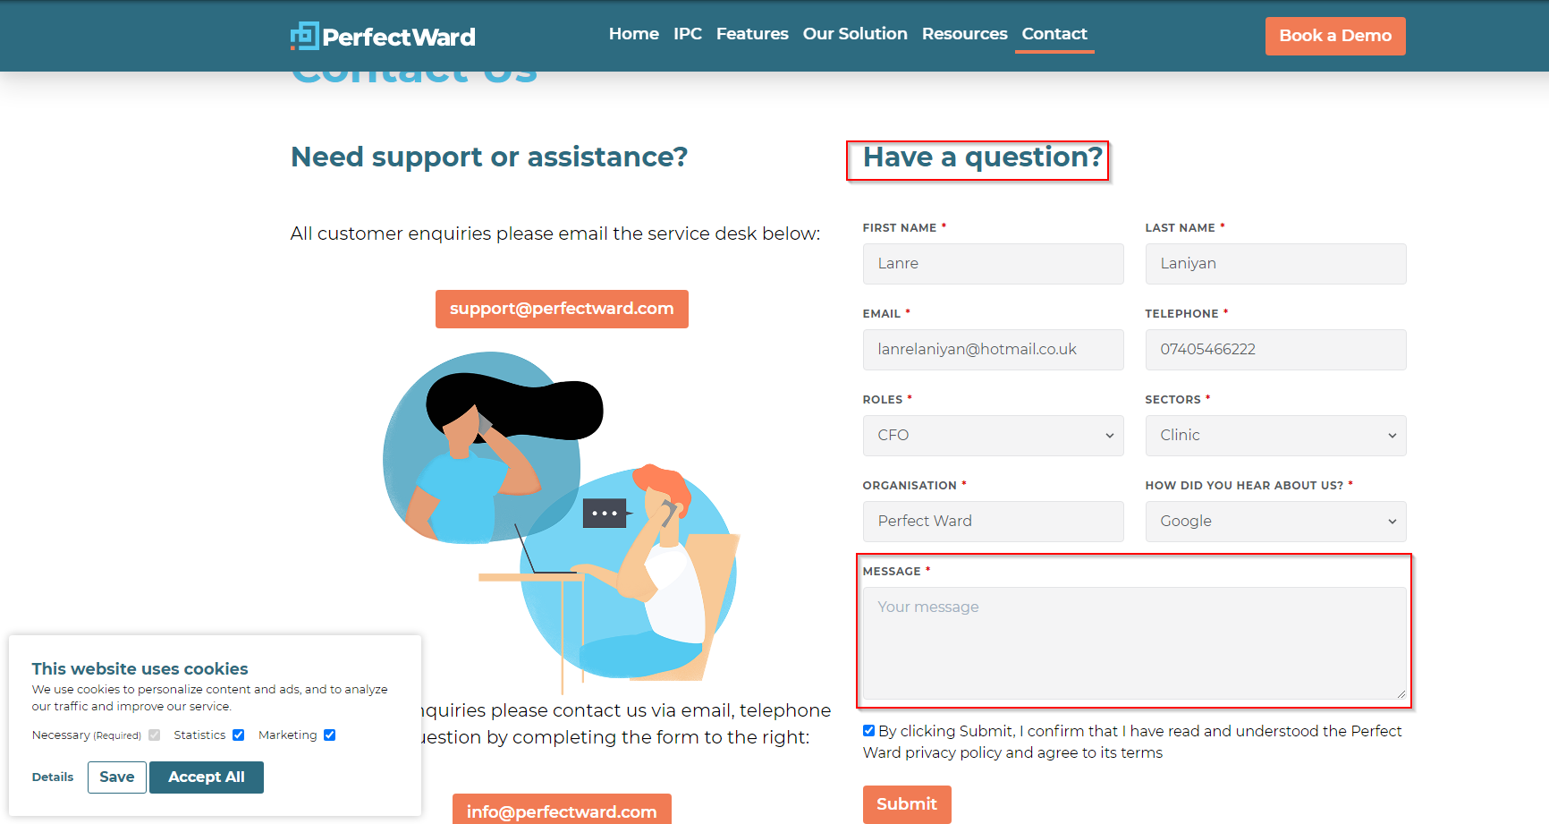
4. Click the submit button and no error message will appear on the top of the form/

